
SPECIALIST MATHS
TRIAL EXAMINATION 1
SOLUTIONS
2005

_____________________________________________________________________

Part I – Multiple-choice answers

1. E 7. B 13. A 19. C 25. E
2. C 8. D 14. E 20. A 26. D
3. E 9. A 15. C 21. A 27. C
4. A 10. D 16. D 22. B 28. E
5. B 11. D 17. B 23. C 29. B
6. E 12. C 18. B 24. B 30. C
___________________________________________________________________________

Part I- Multiple-choice solutions

Question 1

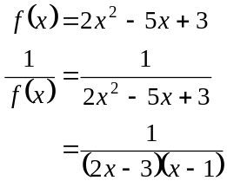
The graph of 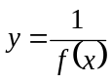 has asymptotes at 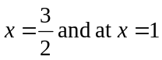.
The answer is E.

Question 2
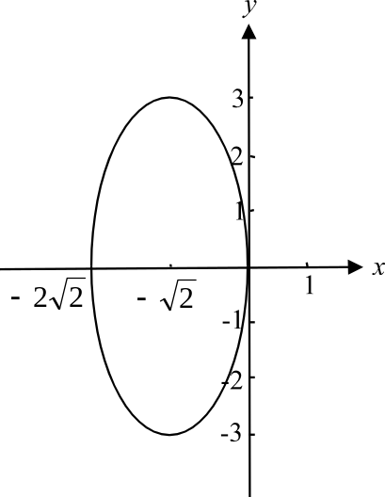

Four obvious tangents are located at
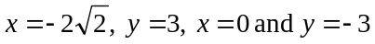.
The answer is C.

Question 3

The domain of 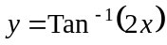is R and so the domain of 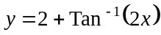 is also R.
The answer is E.

Question 4

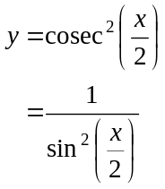
Asymptotes occur when the denominator of 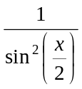 is equal to zero.
Now, 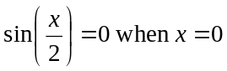 and then again at 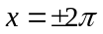. However, we are interested in the graph from 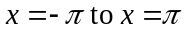. So the only asymptote occurs at 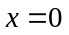.
The answer is A.

Question 5

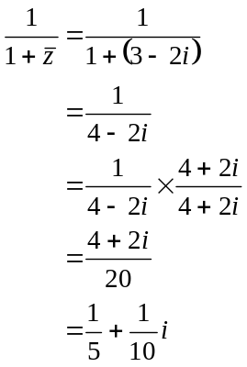
The answer is B.

Question 6
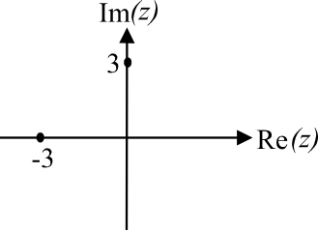
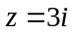
So 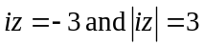
Also 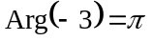
(Note that 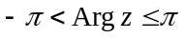.)
The answer is E.

Question 7

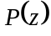 has real coefficients hence the roots of 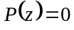 occur in conjugate pairs.
So if i is one root, then –i is another.
So 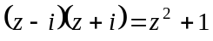 is a factor
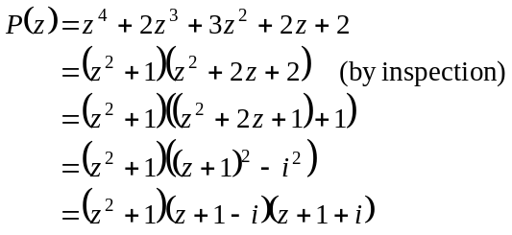
So all the roots are 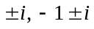.
The answer is B.

Question 8

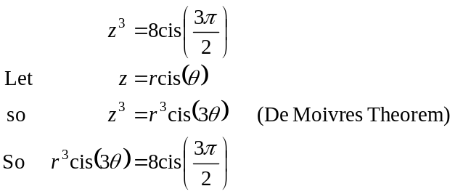
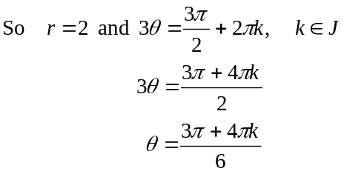
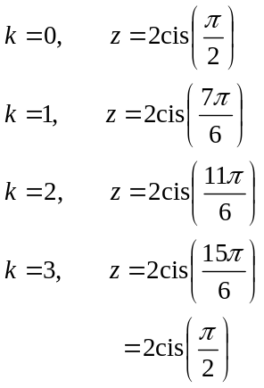
The solutions begin to repeat. Check that your solutions are evenly spaced around a circle with radius 2.
The answer is D.

Question 9

The region is described by
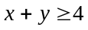
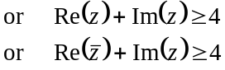
since 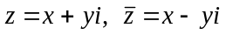
so 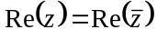.
The answer is A.

Question 10

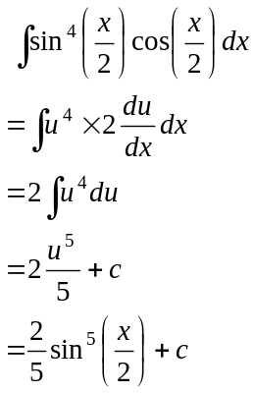
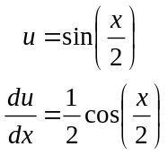
An antiderivative is 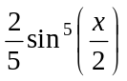.
The answer is D.

Question 11

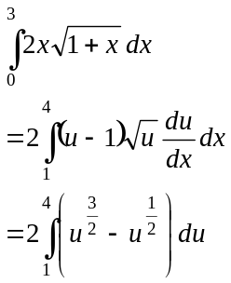
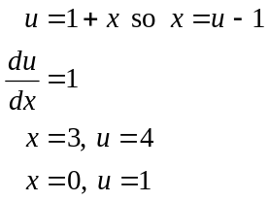
The answer is D.

Question 12

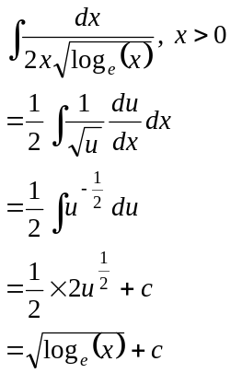
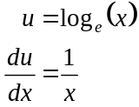
The answer is C.

Question 13

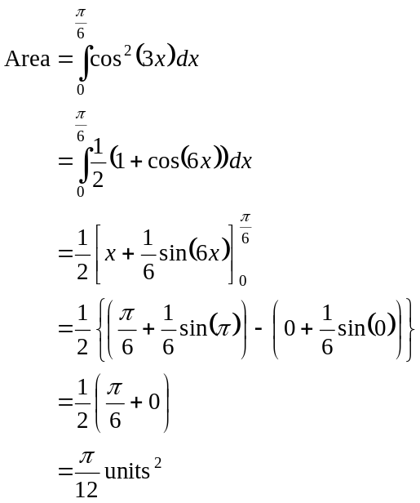
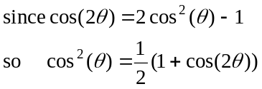
The answer is A.

Question 14

Use a calculator to find this value. It is 5.8875 correct to 4 decimal places.
The answer is E.

Question 15

Stationary points occur when 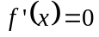, that is at 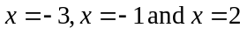.
So options A and B are incorrect.

Now
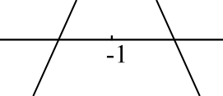
as indicated in the diagram so there is a local maximum
at 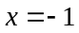.
Options D and E are incorrect
The answer is C.

Question 16

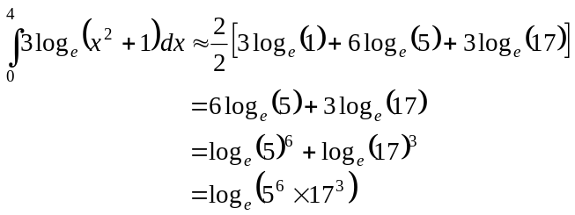
The answer is D.

Question 17

From the formulae sheet,
If 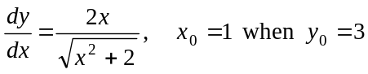
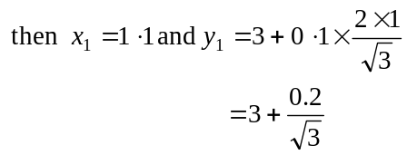
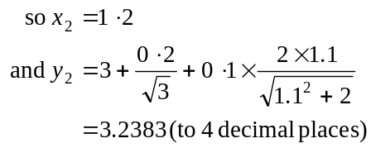
The answer is B.

Question 18

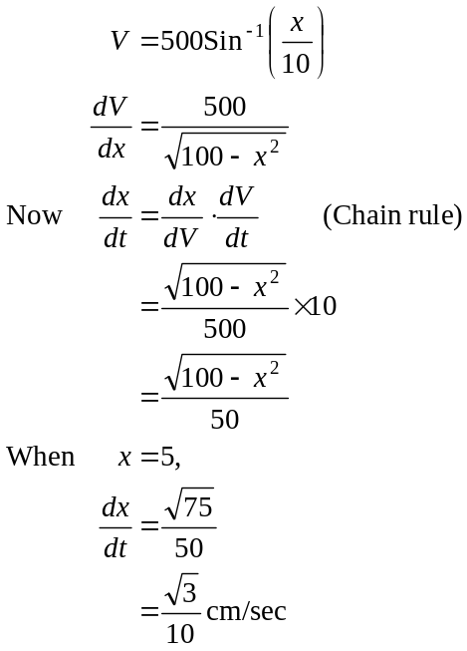
The answer is B.

Question 19

Firstly, only options A and C have a magnitude of 2.
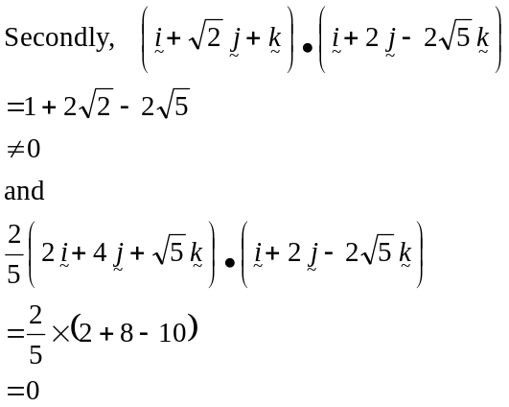
The answer is C.

Question 20
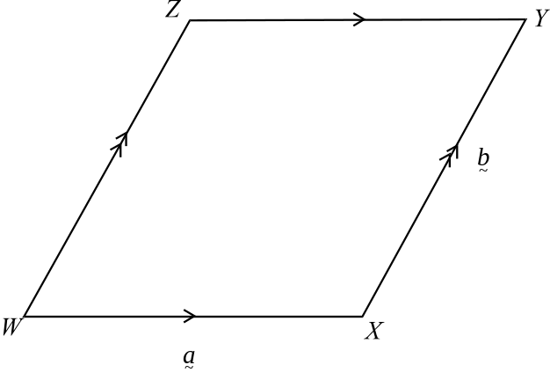

Now, 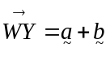 so C and D are incorrect.
Also, 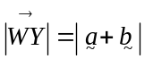.
Note that 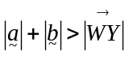
The answer is A.

Question 21

The scalar resolute of 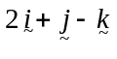 in the direction of 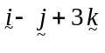 is given by
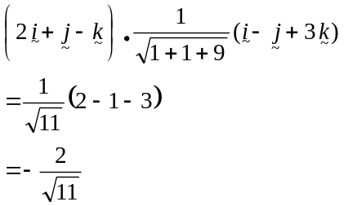
The answer is A.

Question 22

The ball hits the ground when 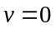; that is at 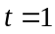. The displacement of the ball in the first second is 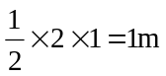.
The answer is B.

Question 23

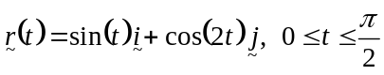
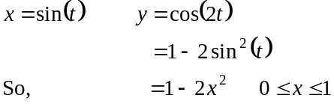
The answer is C.

Question 24

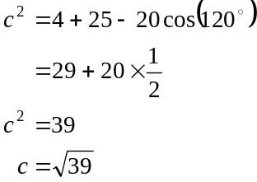
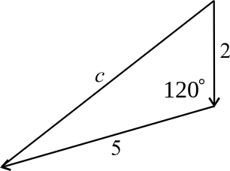

The answer is B.

Question 25

Initial momentum is 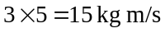.
Momentum after 2 seconds is 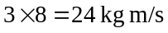.
Change in momentum is 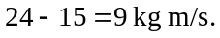
The answer is E.

Question 26

All the normal forces and gravitational forces are correct. All the diagrams that include P are possible. Option D is not possible because if there is no P force, then the tendency of the mass is to slip down the plane and hence the friction force opposes this and should be directed up the plane.
The answer is D.

Question 27
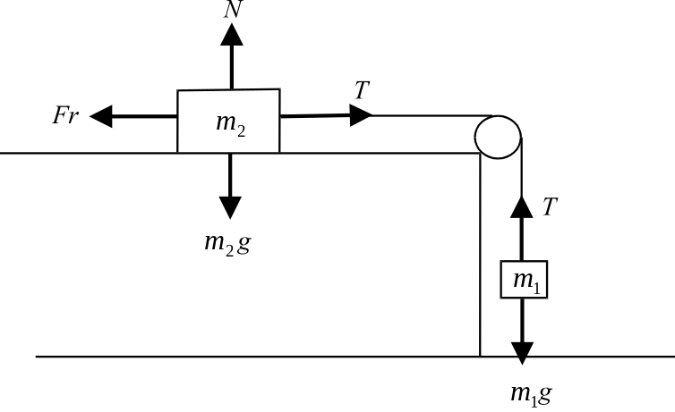

Since 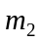 is at the point of moving, 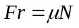.
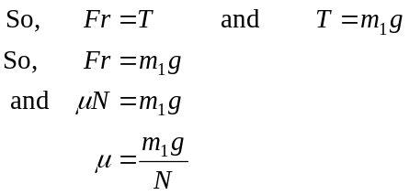
Since 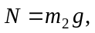
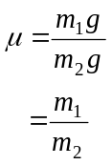
The answer is C.

Question 28

The amount of substance left to react is 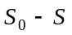.
So 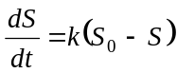.
The answer is E.

Question 29

Since the acceleration is constant we can use the constant acceleration formulae.
Now, 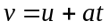 gives us 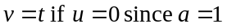 so option A is possible.
Using the same formula, option B is not possible.
Using 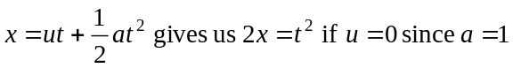 so option C is possible.
Using 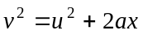 gives us 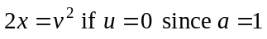 so option D is possible.
Using 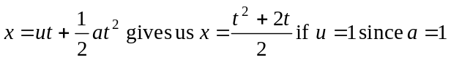 so option E is possible.
So B is not true.
The answer is B.

Question 30

Between 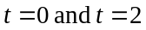 the gradient of the v/t graph is positive and increasing from zero.
This rules out options B, D and E.
Between 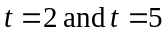 the gradient of the v/t graph is zero and hence the acceleration is zero.
This rules out options A and E.
Between 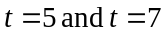the gradient is positive but decreasing to zero.
This rules out options B, D and E.
Only option C describes all these three features.
The answer is C.
PART II

Question 1

Now
We require 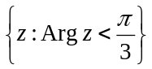.
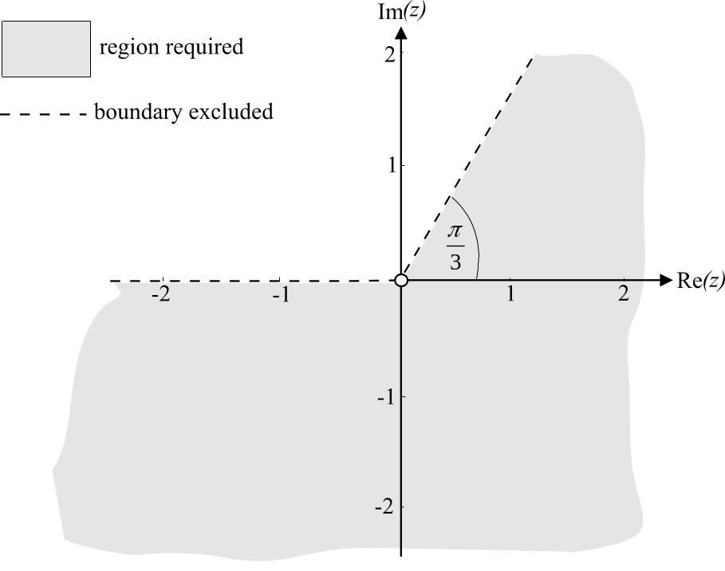

(1 mark) correct region
(1 mark) correct marking of boundaries

Question 2

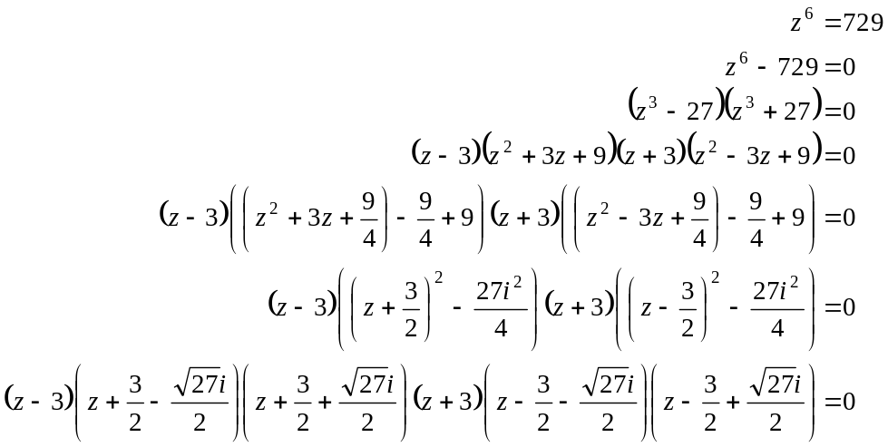
(1 mark)
(1 mark)
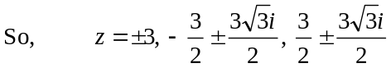
(1 mark)

Question 3
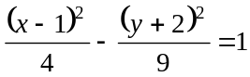
The centre is at 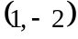.
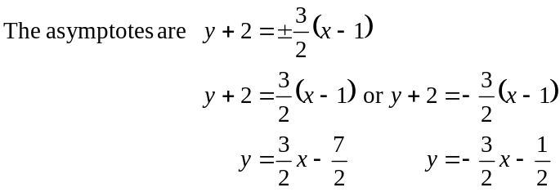
x-intercepts
y-intercepts
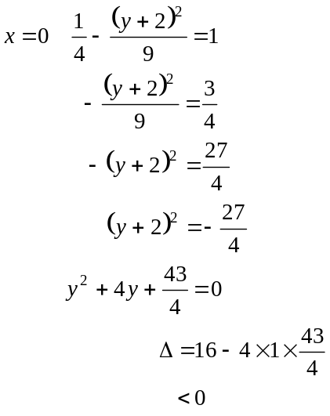
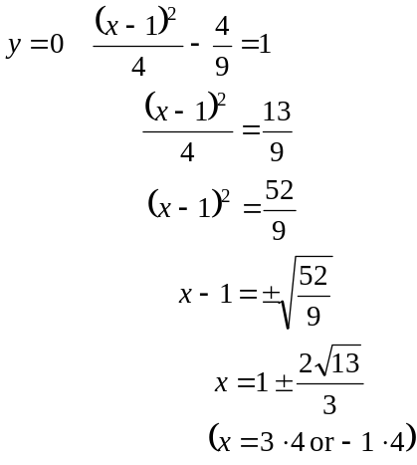

There are no solutions and hence no y-intercepts.
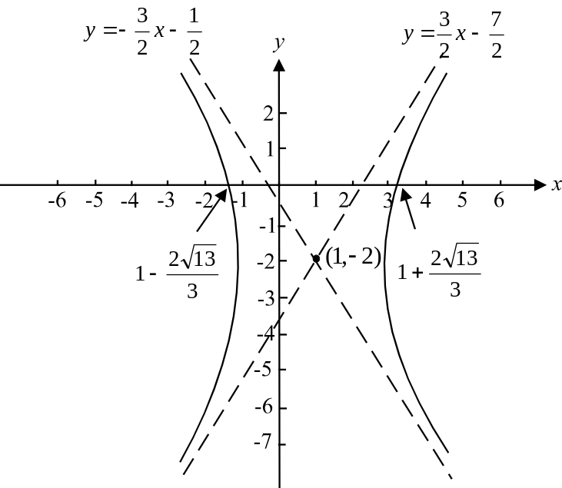

(1 mark) – centre
(1 mark) – asymptotes
(1 mark) – intercepts
(1 mark) – shape of graph
Question 4
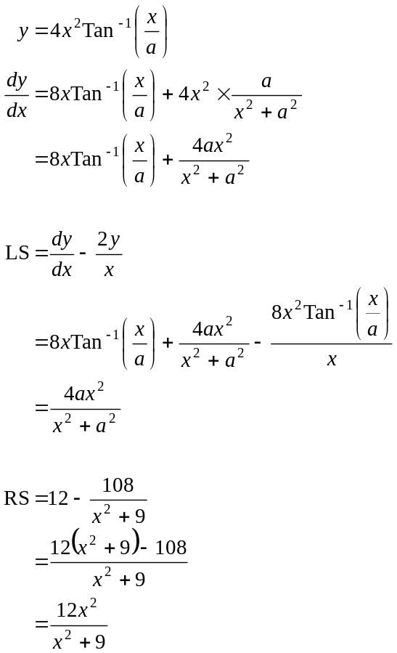
(1 mark)
(1 mark)
Now LS = RS
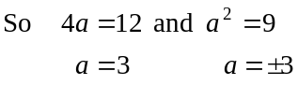
So 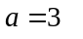(Note that 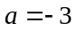 does not satisfy both criteria.)
(1 mark)

Question 5
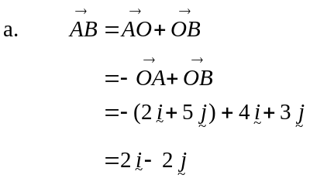
(1 mark)
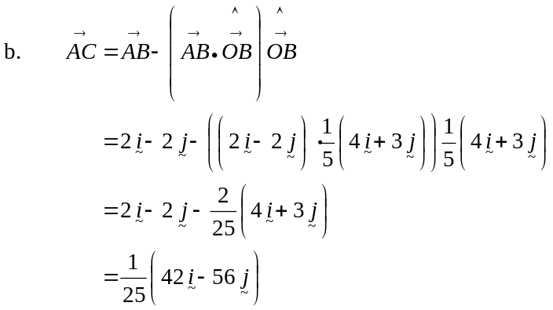
(1mark)
(1 mark)
c. Find 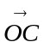.
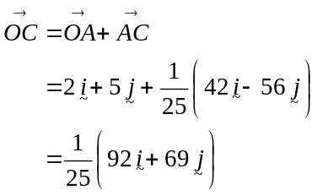
(1 mark)
C is the point 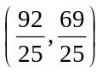. (1 mark)
Question 6
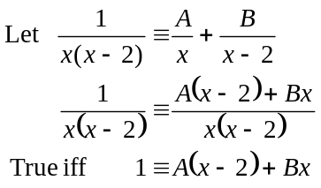
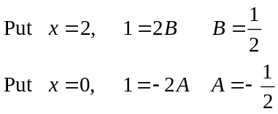
(1 mark)
So 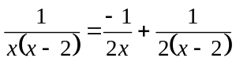
If you have time, check your answer
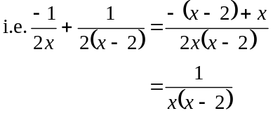
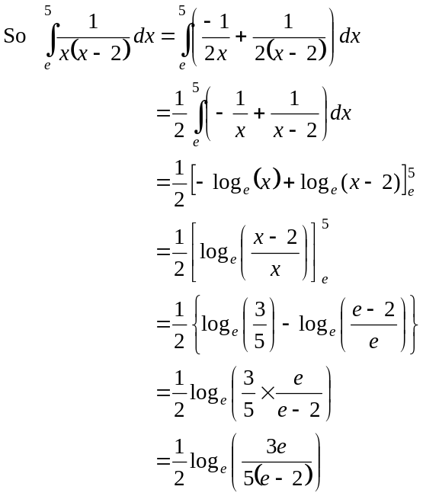
(1 mark)
(1 mark)

Total 20 marks

